Torredemer
2026-05-25
library(car)
## Warning: package 'car' was built under R version 4.2.3
## Loading required package: carData
## Warning: package 'carData' was built under R version 4.2.3
library(readr)
## Warning: package 'readr' was built under R version 4.2.3
dd <- read.csv("C:/Users/Paco/Documents/TFM/bases_de_datos/DB_ea_sports24_afterprocessing.csv", sep=";")
for (i in 1:ncol(dd)) {
if (is.character(dd[, i])) {
dd[, i] <- as.factor(dd[, i])
}
}
names(dd)
## [1] "team_name" "league_name" "top_league"
## [4] "nationality_name" "overall" "attack"
## [7] "midfield" "defence" "home_stadium"
## [10] "def_style" "def_team_width" "def_team_depth"
## [13] "off_build_up_play" "off_chance_creation" "off_team_width"
## [16] "off_players_in_box"
dim(dd)
## [1] 658 16
summary(dd)
## team_name league_name top_league
## Liverpool : 2 Liga Profesional : 29 Min. :0.0000
## River Plate : 2 Major League Soccer: 29 1st Qu.:0.0000
## 1860 München: 1 Championship : 24 Median :0.0000
## Aalesund : 1 League One : 24 Mean :0.1459
## Aberdeen : 1 League Two : 24 3rd Qu.:0.0000
## Abha : 1 La Liga 2 : 22 Max. :1.0000
## (Other) :650 (Other) :506
## nationality_name overall attack midfield
## England : 88 Min. :55.0 Min. :54.00 Min. :55.00
## Germany : 56 1st Qu.:65.0 1st Qu.:65.00 1st Qu.:65.00
## Spain : 42 Median :68.0 Median :68.00 Median :68.00
## Italy : 40 Mean :68.4 Mean :68.77 Mean :68.44
## France : 37 3rd Qu.:71.0 3rd Qu.:72.00 3rd Qu.:71.00
## Argentina: 29 Max. :85.0 Max. :90.00 Max. :86.00
## (Other) :366
## defence home_stadium
## Min. :52.00 Town Park : 55
## 1st Qu.:64.00 Stadion Neder : 47
## Median :67.00 Court Lane : 41
## Mean :67.79 Molton Road (Sheldon Stadium): 37
## 3rd Qu.:70.75 Waldstadion (Fussballstadion): 28
## Max. :84.00 Stade Municipal : 23
## (Other) :427
## def_style def_team_width def_team_depth
## Balanced :425 Min. :31.00 Min. :37.00
## Press after possession loss:112 1st Qu.:51.00 1st Qu.:51.00
## Pressure on heavy touch :121 Median :51.00 Median :51.00
## Mean :52.81 Mean :53.03
## 3rd Qu.:61.00 3rd Qu.:61.00
## Max. :81.00 Max. :81.00
##
## off_build_up_play off_chance_creation off_team_width
## Balanced :197 Balanced :197 Min. :31.00
## Fast build up:189 Direct passing:120 1st Qu.:51.00
## Long ball :120 Forward runs :189 Median :61.00
## Slow build up:152 Possession :152 Mean :59.66
## 3rd Qu.:61.00
## Max. :81.00
##
## off_players_in_box
## Min. :3.000
## 1st Qu.:3.000
## Median :4.000
## Mean :4.196
## 3rd Qu.:5.000
## Max. :8.000
##
sapply(dd, class)
## team_name league_name top_league nationality_name
## "factor" "factor" "integer" "factor"
## overall attack midfield defence
## "integer" "integer" "integer" "integer"
## home_stadium def_style def_team_width def_team_depth
## "factor" "factor" "integer" "integer"
## off_build_up_play off_chance_creation off_team_width off_players_in_box
## "factor" "factor" "integer" "integer"
names(dd)
## [1] "team_name" "league_name" "top_league"
## [4] "nationality_name" "overall" "attack"
## [7] "midfield" "defence" "home_stadium"
## [10] "def_style" "def_team_width" "def_team_depth"
## [13] "off_build_up_play" "off_chance_creation" "off_team_width"
## [16] "off_players_in_box"
dcon <- data.frame (dd$overall, dd$attack, dd$midfield, dd$defence, dd$def_team_width, dd$def_team_depth, dd$off_team_width, dd$off_players_in_box)
dim(dcon)
## [1] 658 8
library(cluster)
d <- dist(dcon[1:658,])
#excluimos el nombre del equipo y su estadio pues no son relevantes
actives <- c(2:8, 10:16)
dissimMatrix <- daisy(dd[,actives], metric = "gower", stand=TRUE)
## Warning in daisy(dd[, actives], metric = "gower", stand = TRUE): binary
## variable(s) 2 treated as interval scaled
distMatrix<-dissimMatrix^2
h1 <- hclust(distMatrix,method="ward.D")
plot(h1)
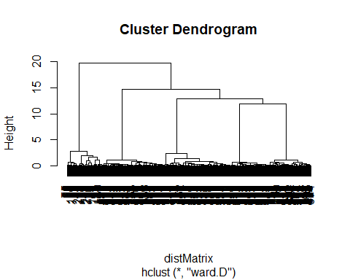
nc = 3
c3 <- cutree(h1,nc)
nc = 4
c4 <- cutree(h1,nc)
table(c3)
## c3
## 1 2 3
## 96 396 166
table(c4)
## c4
## 1 2 3 4
## 96 178 166 218
table(c3,c4)
## c4
## c3 1 2 3 4
## 1 96 0 0 0
## 2 0 178 0 218
## 3 0 0 166 0
names(dd)
## [1] "team_name" "league_name" "top_league"
## [4] "nationality_name" "overall" "attack"
## [7] "midfield" "defence" "home_stadium"
## [10] "def_style" "def_team_width" "def_team_depth"
## [13] "off_build_up_play" "off_chance_creation" "off_team_width"
## [16] "off_players_in_box"
#overall
boxplot(dd[,5]~c3, horizontal=TRUE)
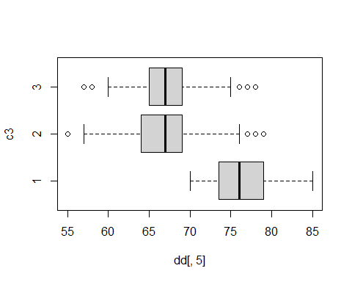
#defence
boxplot(dd[,8]~c3, horizontal=TRUE)
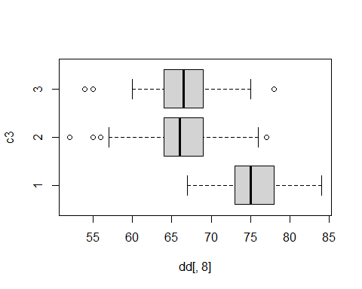
#midfield
boxplot(dd[,7]~c3, horizontal=TRUE)
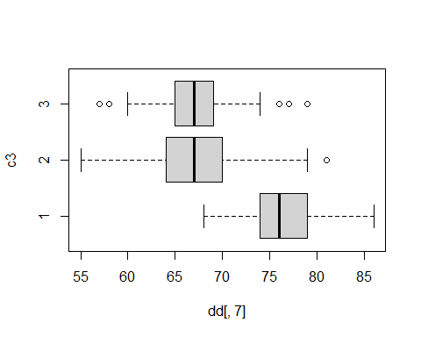
#attack
boxplot(dd[,6]~c3, horizontal=TRUE)
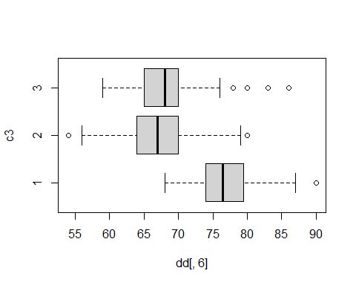
pairs(dcon[,1:8], col=c3)
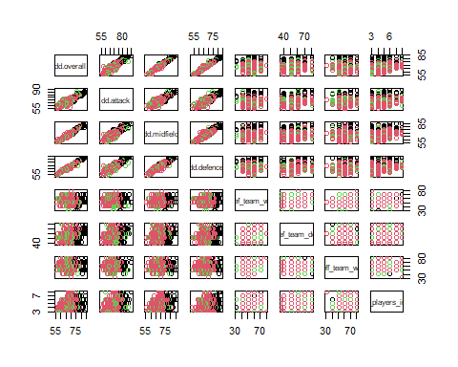
c3 <- as.factor(c3)
plot(dd$overall, dd$defence,col=c3,main="Clustering defence in 3 classes")
legend("topright",levels(c3),pch=1,col=c(1:5), cex=0.6)
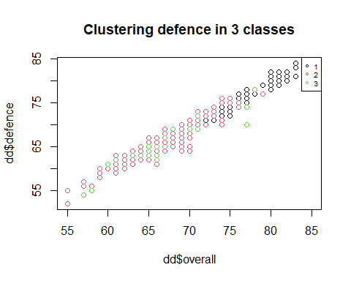
plot(dd$overall, dd$midfield,col=c3,main="Clustering midfield in 3 classes")
legend("topright",levels(c3),pch=1,col=c(1:5), cex=0.6)
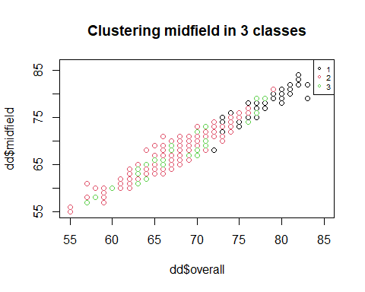
plot(dd$overall, dd$attack,col=c3,main="Clustering attack in 3 classes")
legend("topright",levels(c3),pch=1,col=c(1:5), cex=0.6)
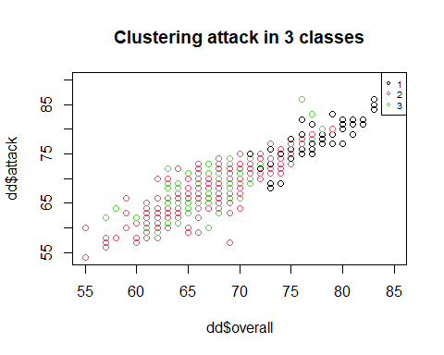
cdg <- aggregate(as.data.frame(dcon),list(c3),mean)
cdg
## Group.1 dd.overall dd.attack dd.midfield dd.defence dd.def_team_width
## 1 1 76.41667 76.78125 76.34375 75.80208 53.50000
## 2 2 66.92424 67.21212 67.00000 66.36111 53.04545
## 3 3 67.30120 67.84940 67.29518 66.55422 51.84337
## dd.def_team_depth dd.off_team_width dd.off_players_in_box
## 1 57.00000 61.83333 4.708333
## 2 52.59091 59.48485 4.151515
## 3 51.79518 58.83133 4.006024
# clusters como factor
c3 <- as.factor(c3)
# recorrer todas las variables
for(v in names(dd)){
cat("\n====================================\n")
cat("VARIABLE:", v, "\n")
# -------------------------------------------------
# VARIABLES NUMÉRICAS
# -------------------------------------------------
if(is.numeric(dd[[v]])){
cat("\nEstadísticos por grupos:\n")
for(g in levels(c3)){
cat("\nGrupo", g, "\n")
print(summary(dd[c3 == g, v]))
}
# boxplot
boxplot(dd[[v]] ~ c3,
horizontal = TRUE,
main = paste(v, "por cluster"),
col = "lightblue")
}
# -------------------------------------------------
# VARIABLES CATEGÓRICAS / FACTOR / BINARIAS
# -------------------------------------------------
else if(is.factor(dd[[v]]) ||
is.character(dd[[v]]) ||
is.logical(dd[[v]])){
# convertir a factor
var_cat <- as.factor(dd[[v]])
# cross table
tabla <- table(var_cat, c3)
cat("\nCross Table:\n")
print(tabla)
# proporciones por cluster
prop <- prop.table(tabla, 2)
# gráfico de líneas
matplot(t(prop),
type = "l",
lty = 1,
lwd = 2,
xaxt = "n",
xlab = "Cluster",
ylab = "Proporción",
main = paste("Distribución de", v))
axis(1,
at = 1:length(levels(c3)),
labels = levels(c3))
legend("topright",
legend = rownames(prop),
col = 1:nrow(prop),
lty = 1,
cex = 0.7)
}
}
##
## ====================================
## VARIABLE: team_name
##
## Cross Table:
## c3
## var_cat 1 2 3
## 1860 München 0 1 0
## Aalesund 0 0 1
## Aberdeen 0 1 0
## Abha 0 1 0
## Academia Puerto Cabello 0 1 0
## Accrington Stanley 0 1 0
## Adana Demirspor 0 1 0
## Adelaide United 0 1 0
## AFC Bournemouth 1 0 0
## AFC Wimbledon 0 1 0
## AGF 0 0 1
## AIK 0 1 0
## Ajaccio 0 0 1
## Ajax 0 1 0
## Al Ahli Jeddah 0 1 0
## Al Ettifaq 0 1 0
## Al Fateh 0 0 1
## Al Fayha 0 1 0
## Al Hazem 0 0 1
## Al Hilal 0 1 0
## Al Ittihad 0 0 1
## Al Khaleej 0 1 0
## Al Nassr 0 0 1
## Al Okhdood 0 1 0
## Al Raed 0 0 1
## Al Riyadh 0 1 0
## Al Shabab 0 0 1
## Al Taawon 0 1 0
## Al Tai 0 1 0
## Al Wahda 0 0 1
## Alanyaspor 0 1 0
## Albacete 0 0 1
## Alcorcón 0 1 0
## Alianza Lima 0 0 1
## Almere City 0 1 0
## Almería 1 0 0
## América Mineiro 0 1 0
## Amiens SC 0 0 1
## Amorebieta 0 1 0
## Anderlecht 0 1 0
## Angers SCO 0 1 0
## Ankaragücü 0 1 0
## Annecy 0 1 0
## Antalyaspor 0 1 0
## Antwerp 0 1 0
## Argentinos Juniors 0 1 0
## Arouca 0 1 0
## Arsenal 1 0 0
## Arsenal de Sarandi 0 0 1
## AS Eupen 0 1 0
## Ascoli 0 1 0
## Aston Villa 1 0 0
## Atalanta 1 0 0
## Athletic Club 1 0 0
## Athletico Paranaense 0 1 0
## ATK Mohun Bagan 0 0 1
## Atlanta United 0 0 1
## Atlético Madrid 1 0 0
## Atlético Mineiro 0 1 0
## Atlético Nacional 0 1 0
## Atlético Tucumán 0 1 0
## Aucas 0 0 1
## Audax Italiano 0 0 1
## Austin 0 1 0
## Austria Klagenfurt 0 1 0
## Austria Lustenau 0 0 1
## Austria Wien 0 0 1
## Auxerre 0 1 0
## AZ Alkmaar 0 1 0
## Banfield 0 0 1
## Barcelona Guayaquil 0 1 0
## Bari 1908 0 1 0
## Barnsley 0 0 1
## Barracas Central 0 1 0
## Barrow 0 0 1
## Basel 0 1 0
## Bastia 0 1 0
## Bayer 04 Leverkusen 1 0 0
## Beijing Guoan 0 1 0
## Belgrano 0 1 0
## Benfica 0 1 0
## Bengaluru 0 0 1
## Beşiktaş 0 1 0
## Birmingham City 0 1 0
## Blackburn Rovers 0 0 1
## Blackpool 0 1 0
## Blau-Weiß Linz 0 1 0
## Blooming 0 1 0
## Boavista 0 1 0
## Boca Juniors 0 0 1
## Bodø / Glimt 0 0 1
## Bohemians 0 1 0
## Bolívar 0 0 1
## Bologna 1 0 0
## Bolton Wanderers 0 1 0
## Bordeaux 0 1 0
## Borussia Dortmund 1 0 0
## Borussia Dortmund II 0 0 1
## Borussia Mönchengladbach 1 0 0
## Botafogo 0 1 0
## Botoşani 0 0 1
## Bradford City 0 1 0
## Bragantino 0 1 0
## Brann 0 1 0
## Brentford 1 0 0
## Brescia 0 1 0
## Brest 1 0 0
## Brighton & Hove Albion 1 0 0
## Brisbane Roar 0 1 0
## Bristol City 0 0 1
## Bristol Rovers 0 1 0
## Brommapojkarna 0 1 0
## Brøndby 0 1 0
## Burgos 0 1 0
## Burnley 1 0 0
## Burton Albion 0 1 0
## Cádiz 1 0 0
## Caen 0 0 1
## Cagliari 1 0 0
## Cambridge United 0 1 0
## Cangzhou Mighty Lions 0 0 1
## Caracas 0 1 0
## Cardiff City 0 1 0
## Carlisle United 0 1 0
## Casa Pia 0 1 0
## Catanzaro 0 0 1
## Celta de Vigo 1 0 0
## Celtic 0 1 0
## Central Coast Mariners 0 1 0
## Central Cordoba SdE 0 1 0
## Cercle Brugge 0 0 1
## Cerro Porteño 0 0 1
## César Vallejo 0 0 1
## CF Montréal 0 1 0
## CFR Cluj 0 1 0
## Changchun Yatai 0 1 0
## Charlotte 0 0 1
## Charlton Athletic 0 1 0
## Chaves 0 1 0
## Chelsea 1 0 0
## Cheltenham Town 0 1 0
## Chengdu Rongcheng 0 1 0
## Chennaiyin 0 0 1
## Chicago Fire 0 1 0
## Cienciano 0 0 1
## Cincinnati 0 1 0
## Cittadella 0 1 0
## Clermont 1 0 0
## Club Brugge 0 1 0
## Cobresal 0 0 1
## Colchester United 0 0 1
## Colo-Colo 0 1 0
## Colón 0 0 1
## Colorado Rapids 0 1 0
## Columbus Crew 0 0 1
## Como 0 1 0
## Concarneau 0 0 1
## Corinthians 0 1 0
## Cork City 0 1 0
## Cosenza 0 1 0
## Coventry City 0 0 1
## Cracovia Kraków 0 1 0
## Crawley Town 0 1 0
## Cremonese 0 1 0
## Crewe Alexandra 0 1 0
## Crystal Palace 1 0 0
## CSM Politehnica Iași 0 1 0
## Daegu 0 1 0
## Daejeon Citizen 0 1 0
## Dalian Professional 0 1 0
## Dallas 0 1 0
## Damac 0 1 0
## Danubio 0 1 0
## Darmstadt 98 1 0 0
## DC United 0 1 0
## Defensa y Justicia 0 1 0
## Degerfors 0 0 1
## Delfin 0 1 0
## Deportes Tolima 0 0 1
## Deportivo Alavés 1 0 0
## Deportivo Binacional 0 0 1
## Deportivo Cuenca 0 1 0
## Deportivo Pereira 0 1 0
## Deportivo Táchira 0 1 0
## Derby County 0 0 1
## Derry City 0 1 0
## Dinamo Bucureşti 0 1 0
## Djurgården 0 0 1
## Doncaster Rovers 0 1 0
## Drogheda United 0 1 0
## DSC Arminia Bielefeld 0 0 1
## Dundalk 0 1 0
## Dundee 0 1 0
## Dunkerque 0 1 0
## Dynamo Dresden 0 1 0
## East Bengal 0 1 0
## Eintracht Braunschweig 0 1 0
## Eintracht Frankfurt 1 0 0
## Elche 0 1 0
## Eldense 0 1 0
## Elfsborg 0 1 0
## Elversberg 0 0 1
## Emelec 0 0 1
## Empoli 1 0 0
## Erzgebirge Aue 0 0 1
## Espanyol 0 1 0
## Estoril 0 0 1
## Estrela Amadora 0 1 0
## Estudiantes 0 0 1
## Estudiantes Mérida 0 1 0
## Everton 1 0 0
## Excelsior 0 1 0
## Exeter City 0 0 1
## Famalicão 0 1 0
## Farense 0 0 1
## Fatih Karagümrük 0 1 0
## FC Andorra 0 1 0
## FC Augsburg 1 0 0
## FC Barcelona 1 0 0
## FC Bayern München 1 0 0
## FC Cartagena 0 1 0
## FC Köln 1 0 0
## FC Twente 0 1 0
## FC Union Berlin 1 0 0
## FC Utrecht 0 1 0
## FC Volendam 0 1 0
## FCSB 0 0 1
## Fenerbahçe 0 0 1
## FeralpiSalò 0 1 0
## Feyenoord 0 1 0
## Fiorentina 1 0 0
## Flamengo 0 1 0
## Fleetwood Town 0 1 0
## Fluminense 0 1 0
## Forest Green Rovers 0 1 0
## Fortaleza 0 1 0
## Fortuna Düsseldorf 0 0 1
## Fortuna Sittard 0 0 1
## Freiburg II 0 1 0
## Frosinone 1 0 0
## FSV Mainz 05 1 0 0
## Fulham 1 0 0
## Galatasaray 0 0 1
## Gangwon 0 1 0
## Gaziantep F.K. 0 0 1
## General Caballero JLM 0 0 1
## Genk 0 1 0
## Genoa 1 0 0
## Gent 0 1 0
## Getafe 1 0 0
## Gil Vicente 0 0 1
## Gillingham 0 1 0
## Gimnasia La Plata 0 0 1
## Girona 1 0 0
## Go Ahead Eagles 0 0 1
## Goa 0 1 0
## Godoy Cruz 0 1 0
## Goiás 0 1 0
## Górnik Zabrze 0 0 1
## Granada 1 0 0
## Grasshopper 0 0 1
## Grenoble Foot 38 0 0 1
## Grimsby Town 0 1 0
## Guabirá 0 1 0
## Guaraní 0 0 1
## Guingamp 0 0 1
## Gwangju 0 0 1
## Häcken 0 0 1
## Hallescher FC 0 1 0
## Halmstad 0 1 0
## Hamburger SV 0 1 0
## HamKam 0 0 1
## Hammarby 0 1 0
## Hannover 96 0 0 1
## Hansa Rostock 0 1 0
## Harrogate Town 0 1 0
## Hartberg 0 1 0
## Hatayspor 0 0 1
## Haugesund 0 1 0
## Hearts 0 0 1
## Heidenheim 1 0 0
## Hellas Verona 1 0 0
## Henan 0 0 1
## Heracles Almelo 0 1 0
## Hermannstadt 0 0 1
## Hertha BSC 0 1 0
## Hibernian 0 0 1
## Holstein Kiel 0 1 0
## Houston Dynamo 0 1 0
## Huddersfield Town 0 0 1
## Huesca 0 0 1
## Hull City 0 1 0
## Huracán 0 0 1
## Hyderabad 0 1 0
## IFK Göteborg 0 1 0
## Incheon United 0 1 0
## Independiente 0 1 0
## Independiente del Valle 0 0 1
## Independiente Medellín 0 1 0
## Ingolstadt 0 1 0
## Instituto 0 1 0
## Inter 1 0 0
## Inter Miami 0 1 0
## Internacional 0 1 0
## Ipswich Town 0 1 0
## İstanbul Başakşehir 0 1 0
## İstanbulspor 0 0 1
## Jagiellonia Białystok 0 1 0
## Jahn Regensburg 0 0 1
## Jamshedpur 0 0 1
## Jeju United 0 0 1
## Jeonbuk Motors 0 1 0
## Junior 0 1 0
## Juventus 1 0 0
## Kaiserslautern 0 1 0
## Kalmar 0 1 0
## Karlsruher SC 0 1 0
## Kasımpaşa 0 1 0
## Kayserispor 0 1 0
## Kerala Blasters 0 1 0
## Kilmarnock 0 1 0
## København 0 1 0
## Konyaspor 0 1 0
## Korona Kielce 0 1 0
## Kortrijk 0 1 0
## LA Galaxy 0 1 0
## Lanús 0 1 0
## Las Palmas 1 0 0
## LASK Linz 0 0 1
## Lausanne Sport 0 0 1
## Laval 0 0 1
## Lazio 1 0 0
## LDU Quito 0 1 0
## Le Havre 1 0 0
## Lecce 1 0 0
## Lecco 0 1 0
## Lech Poznań 0 1 0
## Leeds United 0 0 1
## Leganés 0 1 0
## Legia Warszawa 0 1 0
## Leicester City 0 1 0
## Lens 1 0 0
## Levante 0 1 0
## Leyton Orient 0 1 0
## Libertad 0 1 0
## Lille 1 0 0
## Lillestrøm 0 1 0
## Lincoln City 0 1 0
## Liverpool 1 1 0
## Livingston 0 1 0
## ŁKS Łódź 0 1 0
## Lorient 1 0 0
## Los Angeles FC 0 1 0
## Lugano 0 0 1
## Luton Town 1 0 0
## Luzern 0 1 0
## Lyngby 0 0 1
## Macarthur 0 0 1
## Magallanes 0 0 1
## Magdeburg 0 1 0
## Mallorca 1 0 0
## Malmö FF 0 1 0
## Manchester City 1 0 0
## Manchester United 1 0 0
## Mansfield Town 0 1 0
## Mechelen 0 1 0
## Meizhou Hakka 0 1 0
## Melbourne City 0 1 0
## Melbourne Victory 0 1 0
## Melgar 0 0 1
## Metropolitanos 0 0 1
## Metz 1 0 0
## Middlesbrough 0 1 0
## Midtjylland 0 0 1
## Milan 1 0 0
## Millonarios 0 1 0
## Millwall 0 1 0
## Milton Keynes Dons 0 1 0
## Minnesota United 0 1 0
## Mirandés 0 1 0
## Mjällby 0 1 0
## Modena 0 1 0
## Molde 0 1 0
## Monaco 1 0 0
## Monagas 0 1 0
## Montpellier 1 0 0
## Monza 1 0 0
## Morecambe 0 1 0
## Moreirense 0 1 0
## Motherwell 0 0 1
## MSV Duisburg 0 1 0
## Mumbai City 0 1 0
## Nacional 0 0 1
## Nantes 1 0 0
## Nantong Zhiyun 0 1 0
## Napoli 1 0 0
## Nashville SC 0 0 1
## NEC 0 1 0
## New England 0 1 0
## New York City 0 1 0
## New York RB 0 1 0
## Newcastle Jets 0 1 0
## Newcastle United 1 0 0
## Newell's Old Boys 0 1 0
## Newport County 0 1 0
## Nice 1 0 0
## Nordsjælland 0 1 0
## Norrköping 0 1 0
## Northampton Town 0 1 0
## NorthEast United 0 1 0
## Norwich City 0 1 0
## Nottingham Forest 1 0 0
## Notts County 0 1 0
## Nürnberg 0 1 0
## Ñublense 0 0 1
## OB 0 0 1
## Odd 0 1 0
## Odisha FC 0 1 0
## OH Leuven 0 1 0
## Olimpia 0 1 0
## Olympique de Marseille 1 0 0
## Olympique Lyonnais 1 0 0
## Oriente Petrolero 0 1 0
## Orlando City 0 1 0
## Osasuna 1 0 0
## Osnabrück 0 1 0
## Oțelul Galați 0 1 0
## Oxford United 0 1 0
## Paderborn 0 0 1
## Palermo 0 1 0
## Palestino 0 0 1
## Palmaflor del Trópico 0 1 0
## Palmeiras 0 1 0
## Paris 0 1 0
## Paris Saint Germain 1 0 0
## Parma 0 1 0
## Patronato 0 0 1
## Pau 0 0 1
## PEC Zwolle 0 1 0
## Pendikspor 0 1 0
## Peñarol 0 0 1
## Perth Glory 0 1 0
## Peterborough United 0 1 0
## Petrolul 52 0 1 0
## Philadelphia Union 0 1 0
## Piast Gliwice 0 1 0
## Pisa 0 0 1
## Platense 0 1 0
## Plymouth Argyle 0 1 0
## Pogoń Szczecin 0 1 0
## Pohang Steelers 0 1 0
## Port Vale 0 1 0
## Portimonense 0 1 0
## Portland Timbers 0 0 1
## Porto 0 1 0
## Portsmouth 0 1 0
## Preston North End 0 0 1
## Preußen Münster 0 1 0
## PSV 0 0 1
## Punjab 0 1 0
## Puszcza Niepołomice 0 1 0
## Qingdao Hainiu 0 1 0
## Queens Park Rangers 0 1 0
## Quevilly Rouen 0 1 0
## Racing Club 0 1 0
## Racing Ferrol 0 0 1
## Racing Santander 0 0 1
## Radomiak Radom 0 1 0
## Raków Częstochowa 0 1 0
## Randers 0 1 0
## Rangers 0 1 0
## Rapid Bucuresti 0 0 1
## Rapid Wien 0 1 0
## Rayo Vallecano 1 0 0
## RB Leipzig 1 0 0
## Reading 0 1 0
## Real Betis 1 0 0
## Real Madrid 1 0 0
## Real Oviedo 0 1 0
## Real Salt Lake 0 0 1
## Real Sociedad 1 0 0
## Real Valladolid 0 0 1
## Real Zaragoza 0 1 0
## Reggiana 0 1 0
## Rennes 1 0 0
## Rheindorf Altach 0 1 0
## Rio Ave 0 1 0
## Rionegro Águilas 0 0 1
## River Plate 0 2 0
## Rizespor 0 1 0
## RKC Waalwijk 0 1 0
## Rodez 0 1 0
## Roma 1 0 0
## Rosario Central 0 1 0
## Rosenborg 0 1 0
## Ross County 0 1 0
## Rot-Weiss Essen 0 1 0
## Rotherham United 0 1 0
## Ruch Chorzów 0 1 0
## RWDM 0 0 1
## Saarbrücken 0 1 0
## Saint-Étienne 0 0 1
## Saint Louis City 0 0 1
## Salernitana 1 0 0
## Salford City 0 1 0
## Salzburg 0 0 1
## Sampdoria 0 1 0
## Samsunspor 0 1 0
## San Jose Earthquakes 0 1 0
## San Lorenzo 0 1 0
## Sandefjord 0 1 0
## Sandhausen 0 1 0
## Santa Fe 0 0 1
## Santos 0 1 0
## São Paulo 0 1 0
## Sarmiento 0 0 1
## Sarpsborg 08 0 1 0
## Sassuolo 1 0 0
## SC Freiburg 1 0 0
## SC Heerenveen 0 0 1
## Schalke 04 0 1 0
## SD Eibar 0 1 0
## Seattle Sounders 0 1 0
## Seoul 0 0 1
## Sepsi 0 1 0
## Servette 0 0 1
## Sevilla 1 0 0
## Shamrock Rovers 0 1 0
## Shandong Taishan 0 1 0
## Shanghai Port 0 1 0
## Shanghai Shenhua 0 1 0
## Sheffield United 1 0 0
## Sheffield Wednesday 0 1 0
## Shelbourne 0 1 0
## Shenzhen 0 1 0
## Shrewsbury Town 0 1 0
## Silkeborg 0 0 1
## Sint-Truiden 0 0 1
## Sirius 0 1 0
## Sivasspor 0 1 0
## Śląsk Wrocław 0 1 0
## Sligo Rovers 0 1 0
## Southampton 0 1 0
## Sparta Rotterdam 0 0 1
## Spezia 0 0 1
## Sporting Braga 0 1 0
## Sporting Charleroi 0 0 1
## Sporting CP 0 0 1
## Sporting Cristal 0 1 0
## Sporting Gijón 0 0 1
## Sporting Kansas City 0 1 0
## Sportivo Ameliano 0 0 1
## SpVgg Greuther Fürth 0 1 0
## SSC Farul 0 1 0
## St Patrick's 0 0 1
## St. Gallen 0 1 0
## St. Johnstone 0 1 0
## St. Mirren 0 1 0
## St. Pauli 0 1 0
## Stabæk 0 1 0
## Stade de Reims 1 0 0
## Stade Lausanne-Ouchy 0 0 1
## Stal Mielec 0 1 0
## Standard Liège 0 1 0
## Stevenage 0 1 0
## Stockport County 0 1 0
## Stoke City 0 0 1
## Strasbourg 1 0 0
## Strømsgodset 0 0 1
## Sturm Graz 0 0 1
## Südtirol 0 1 0
## Sunderland 0 1 0
## Sutton United 0 0 1
## Suwon 0 0 1
## Suwon Bluewings 0 0 1
## Swansea City 0 1 0
## Swindon Town 0 1 0
## Sydney 0 1 0
## Tacuary 0 0 1
## Talleres Córdoba 0 1 0
## Tenerife 0 1 0
## Ternana 0 1 0
## The Strongest 0 0 1
## Tianjin Jinmen Tiger 0 1 0
## Tigre 0 0 1
## Torino 1 0 0
## Toronto 0 1 0
## Tottenham Hotspur 1 0 0
## Toulouse 1 0 0
## Trabzonspor 0 1 0
## Tranmere Rovers 0 1 0
## Tromsø 0 1 0
## Troyes 0 1 0
## TSG Hoffenheim 1 0 0
## U Craiova 1948 0 1 0
## UCD 0 1 0
## Udinese 1 0 0
## Ulm 0 1 0
## Ulsan 0 1 0
## Union Saint-Gilloise 0 1 0
## Unión Santa Fe 0 1 0
## Universidad Católica 0 1 0
## Universitario 0 0 1
## Universitatea Cluj 0 1 0
## Universitatea Craiova 0 0 1
## Unterhaching 0 1 0
## UTA Arad 0 1 0
## Valencia 1 0 0
## Valenciennes 0 1 0
## Vålerenga 0 1 0
## Vancouver Whitecaps 0 0 1
## Varberg BoIS 0 1 0
## Värnamo 0 0 1
## Vejle 0 1 0
## Vélez Sarsfield 0 1 0
## Venezia 0 1 0
## Verl 0 1 0
## VfB Lübeck 0 0 1
## VfB Stuttgart 1 0 0
## VfL Bochum 1848 1 0 0
## VfL Wolfsburg 1 0 0
## Viborg 0 1 0
## Viking 0 0 1
## Viktoria Köln 0 0 1
## Villarreal 1 0 0
## Villarreal II 0 1 0
## Vitesse 0 1 0
## Vitória SC 0 0 1
## Vizela 0 1 0
## Voluntari 0 1 0
## Waldhof Mannheim 0 0 1
## Walsall 0 1 0
## Warta Poznań 0 0 1
## Watford 0 0 1
## Wehen Wiesbaden 0 1 0
## Wellington Phoenix 0 0 1
## Werder Bremen 1 0 0
## West Bromwich Albion 0 1 0
## West Ham United 1 0 0
## Westerlo 0 1 0
## Western Sydney Wanderers 0 0 1
## Western United 0 1 0
## Widzew Lodz 0 1 0
## Wigan Athletic 0 1 0
## Winterthur 0 0 1
## Wolfsberger AC 0 0 1
## Wolverhampton Wanderers 1 0 0
## Wrexham 0 1 0
## WSG Tirol 0 1 0
## Wuhan Three Towns 0 1 0
## Wycombe Wanderers 0 1 0
## Young Boys 0 0 1
## Yverdon Sport 0 1 0
## Zagłębie Lubin 0 1 0
## Zhejiang 0 1 0
## Zürich 0 1 0
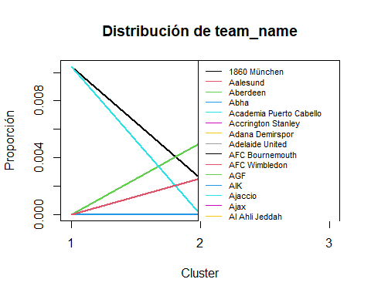
##
## ====================================
## VARIABLE: league_name
##
## Cross Table:
## c3
## var_cat 1 2 3
## 2. Bundesliga 0 14 4
## 3. Liga 0 13 7
## A-League 0 9 3
## Allsvenskan 0 12 4
## Bundesliga 18 0 0
## Bundesliga AT 0 6 6
## Championship 0 16 8
## Ekstraklasa 0 16 2
## Eliteserien 0 11 5
## Eredivisie 0 13 5
## Jupiler Pro League 0 12 4
## K League 1 0 7 5
## La Liga 20 0 0
## La Liga 2 0 16 6
## League One 0 21 3
## League Two 0 21 3
## Liga 1 0 11 5
## Liga BetPlay 0 5 3
## Liga De Futbol Prof 0 4 2
## Liga Portugal 0 13 5
## Liga Pro 0 4 3
## Liga Profesional 0 19 10
## Ligue 1 18 0 0
## Ligue 2 0 11 9
## Major League Soccer 0 21 8
## Premier Division 0 9 1
## Premier League 20 0 0
## Premiership 0 9 3
## Primera Division CL 0 2 5
## Primera Division PE 0 1 6
## Primera División PY 0 2 5
## Primera Division UY 0 3 2
## Primera Division VE 0 5 1
## Pro League 0 11 7
## Serie A 20 0 0
## Serie A BR 0 14 0
## Serie B 0 17 3
## Super League CH 0 5 7
## Super League CN 0 14 2
## Super League IN 0 8 4
## Super Lig 0 15 5
## Superliga 0 6 5
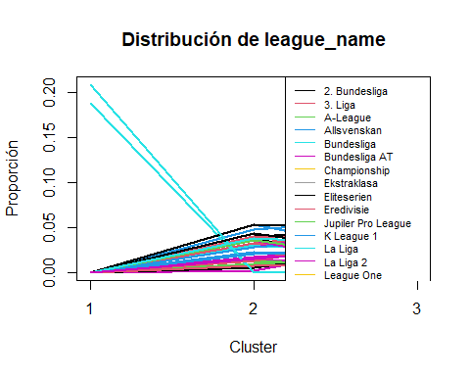
##
## ====================================
## VARIABLE: top_league
##
## Estadísticos por grupos:
##
## Grupo 1
## Min. 1st Qu. Median Mean 3rd Qu. Max.
## 1 1 1 1 1 1
##
## Grupo 2
## Min. 1st Qu. Median Mean 3rd Qu. Max.
## 0 0 0 0 0 0
##
## Grupo 3
## Min. 1st Qu. Median Mean 3rd Qu. Max.
## 0 0 0 0 0 0
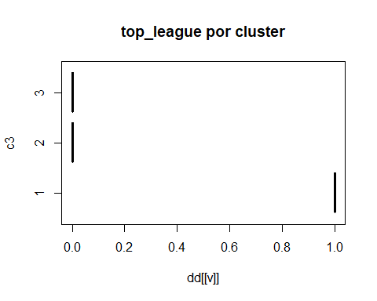
##
## ====================================
## VARIABLE: nationality_name
##
## Cross Table:
## c3
## var_cat 1 2 3
## Argentina 0 19 10
## Australia 0 9 2
## Austria 0 6 6
## Belgium 0 12 4
## Bolivia 0 4 2
## Brazil 0 14 0
## Canada 0 2 1
## Chile 0 2 5
## China PR 0 14 2
## Colombia 0 5 3
## Denmark 0 6 5
## Ecuador 0 4 3
## England 20 54 14
## France 17 11 9
## Germany 18 27 11
## India 0 8 4
## Italy 20 17 3
## Korea Republic 0 7 5
## Monaco 1 0 0
## Netherlands 0 13 5
## New Zealand 0 0 1
## Northern Ireland 0 1 0
## Norway 0 11 5
## Paraguay 0 2 5
## Peru 0 1 6
## Poland 0 16 2
## Portugal 0 13 5
## Republic of Ireland 0 8 1
## Romania 0 11 5
## Saudi Arabia 0 11 7
## Scotland 0 9 3
## Spain 20 16 6
## Sweden 0 12 4
## Switzerland 0 5 7
## Turkey 0 15 5
## United States 0 19 7
## Uruguay 0 3 2
## Venezuela 0 5 1
## Wales 0 4 0
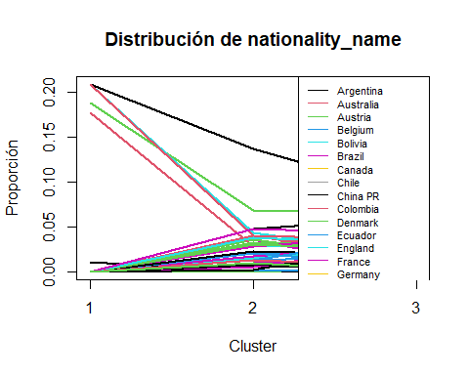
##
## ====================================
## VARIABLE: overall
##
## Estadísticos por grupos:
##
## Grupo 1
## Min. 1st Qu. Median Mean 3rd Qu. Max.
## 70.00 73.75 76.00 76.42 79.00 85.00
##
## Grupo 2
## Min. 1st Qu. Median Mean 3rd Qu. Max.
## 55.00 64.00 67.00 66.92 69.00 79.00
##
## Grupo 3
## Min. 1st Qu. Median Mean 3rd Qu. Max.
## 57.0 65.0 67.0 67.3 69.0 78.0
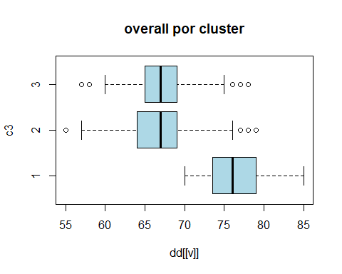
##
## ====================================
## VARIABLE: attack
##
## Estadísticos por grupos:
##
## Grupo 1
## Min. 1st Qu. Median Mean 3rd Qu. Max.
## 68.00 74.00 76.50 76.78 79.25 90.00
##
## Grupo 2
## Min. 1st Qu. Median Mean 3rd Qu. Max.
## 54.00 64.00 67.00 67.21 70.00 80.00
##
## Grupo 3
## Min. 1st Qu. Median Mean 3rd Qu. Max.
## 59.00 65.00 68.00 67.85 70.00 86.00
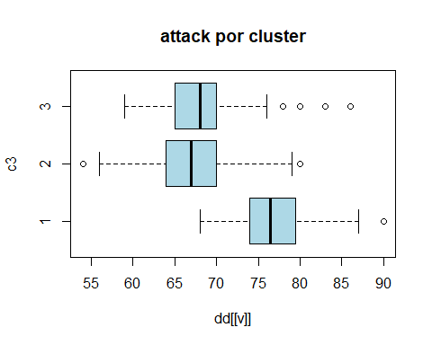
##
## ====================================
## VARIABLE: midfield
##
## Estadísticos por grupos:
##
## Grupo 1
## Min. 1st Qu. Median Mean 3rd Qu. Max.
## 68.00 74.00 76.00 76.34 79.00 86.00
##
## Grupo 2
## Min. 1st Qu. Median Mean 3rd Qu. Max.
## 55 64 67 67 70 81
##
## Grupo 3
## Min. 1st Qu. Median Mean 3rd Qu. Max.
## 57.0 65.0 67.0 67.3 69.0 79.0
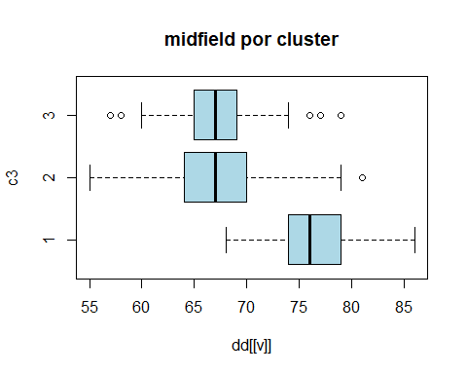
##
## ====================================
## VARIABLE: defence
##
## Estadísticos por grupos:
##
## Grupo 1
## Min. 1st Qu. Median Mean 3rd Qu. Max.
## 67.0 73.0 75.0 75.8 78.0 84.0
##
## Grupo 2
## Min. 1st Qu. Median Mean 3rd Qu. Max.
## 52.00 64.00 66.00 66.36 69.00 77.00
##
## Grupo 3
## Min. 1st Qu. Median Mean 3rd Qu. Max.
## 54.00 64.00 66.50 66.55 69.00 78.00
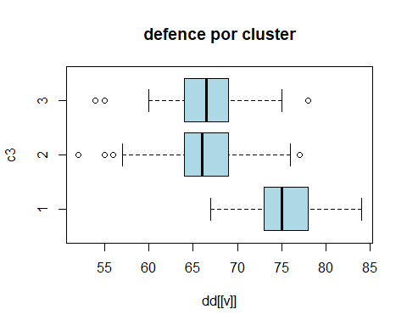
##
## ====================================
## VARIABLE: home_stadium
##
## Cross Table:
## c3
## var_cat 1 2 3
## _Longville Stadium 0 13 2
## _Oktigann Park 0 2 3
## Aloha Park (Generic Oceania 2) 0 2 6
## Anfield 1 0 0
## Arena d'Oro 0 8 7
## Arena del Centenario (Estadio del Pueblo) 0 12 5
## BayArena 1 0 0
## BC Place Stadium 0 0 1
## Benteler-Arena 0 0 1
## BMO Stadium 0 1 0
## BORUSSIA-PARK 1 0 0
## Bramall Lane 1 0 0
## Cardiff City Stadium 0 1 0
## Carrow Road 0 1 0
## Celtic Park 0 1 0
## Coliseum Alfonso Pérez 1 0 0
## Court Lane 2 31 8
## Craven Cottage 1 0 0
## Crown Lane 1 14 4
## Decathlon Arena 1 0 0
## Deutsche Bank Park 1 0 0
## Dignity Health Sports Park 0 1 0
## Düsseldorf-Arena 0 0 1
## Eastpoint Arena (Football Ground) 0 2 1
## El Alcoraz 0 0 1
## El Libertador (La Bombastico) 1 5 4
## El Monumento (Estadio Latino) 0 4 2
## Elland Road 0 0 1
## Emirates Stadium 1 0 0
## Estadio Abanca-Balaídos 1 0 0
## Estadio Benito Villamarín 1 0 0
## Estadio Ciutat de València 0 1 0
## Estádio da Luz 0 1 0
## Estadio de Gran Canaria 1 0 0
## Estadio de la Cerámica 1 1 0
## Estadio de las Artes (Generic Stadium NG) 1 5 4
## Estadio de Mendizorroza 1 0 0
## Estadio de Montilivi 1 0 0
## Estadio de Vallecas 1 0 0
## Estádio do Dragão 0 1 0
## Estadio El Sadar 1 0 0
## Estadio José Zorrilla 0 0 1
## Estadio Libertadores de América 0 1 0
## Estadio Martínez Valero 0 1 0
## Estadio Mestalla 1 0 0
## Estadio Nacional (El Medio) 0 7 4
## Estadio Nuevo Los Cármenes 1 0 0
## Estadio Presidente Perón (El Cilindro) 0 1 0
## Estadio San Mamés 1 0 0
## Estadio Santiago Bernabéu 1 0 0
## Etihad Stadium 1 0 0
## Euro Arena 3 15 4
## Euro Park 1 10 4
## Europa-Park Stadion 1 0 0
## Forest Park Stadium (Square Ground) 4 10 2
## Fratton Park 0 1 0
## Goodison Park 1 0 0
## Groupama Stadium 1 0 0
## HDI-Arena 0 0 1
## Ibrox Stadium 0 1 0
## Ivy Lane 1 15 6
## Johan Cruijff ArenA 0 1 0
## Juventus Arena 1 0 0
## King Abdullah Sports City 0 1 1
## King Fahd International Stadium 0 1 0
## King Power Stadium 0 1 0
## Kirklees Stadium 0 0 1
## Kiyan Prince Foundation 0 1 0
## La Bombonera 0 0 1
## London Stadium 1 0 0
## Lumen Field 0 1 0
## Max-Morlock-Stadion 0 1 0
## Mercedes-Benz Arena (Stuttgart) 1 0 0
## Mercedes-Benz Stadium 0 0 1
## Millerntor-Stadion 0 1 0
## MKM Stadium 0 1 0
## Molineux Stadium 1 0 0
## Molton Road (Sheldon Stadium) 2 25 10
## Municipal de Butarque 0 1 0
## Municipal de Ipurua 0 1 0
## Nuevo Mirandilla 1 0 0
## O Dromo 0 14 3
## Old Trafford 1 0 0
## Olympiastadion 0 1 0
## Opel Arena 1 0 0
## Orange Vélodrome 1 0 0
## Parc des Princes 1 0 0
## Philips Stadion 0 0 1
## Power Horse Stadium 1 0 0
## PreZero Arena 1 0 0
## Providence Park 0 0 1
## Ramón Sánchez-Pizjuán 1 0 0
## RCDE Stadium 0 1 0
## Reale Arena 1 0 0
## Red Bull Arena (Leipzig) 1 0 0
## Red Bull Arena (New Jersey) 0 1 0
## RheinEnergieStadion 1 0 0
## Riverside Stadium 0 1 0
## San Siro 2 0 0
## Sanderson Park (FIFA 13 NEW generic) 3 8 4
## SchücoArena 0 0 1
## Selhurst Park 1 0 0
## Signal Iduna Park 1 0 0
## Sportpark Ronhof Thomas Sommer 0 1 0
## St. James' Park 1 0 0
## St. Mary's Stadium 0 1 0
## Stade Kokoto (Generic Africa 2) 0 10 5
## Stade Municipal 3 11 9
## Stadio Classico 4 10 7
## Stadion 23. Maj 0 8 6
## Stadion An der Alten Försterei 1 0 0
## Stadion Europa (Generic Europe 2) 2 11 0
## Stadion Hanguk 0 7 1
## Stadion Neder 1 31 15
## Stadion Olympik 0 10 1
## Stadium of Light 0 1 0
## Stadium Random 4 1 1
## Stadium_450 1 0 0
## Stamford Bridge 1 0 0
## Stoke City FC Stadium 0 0 1
## Swansea.com Stadium 0 1 0
## The Amex Stadium 1 0 0
## The City Ground 1 0 0
## The Hawthorns 0 1 0
## Tottenham Hotspur Stadium 1 0 0
## Town Park 0 42 13
## Turf Moor 1 0 0
## Udinese Arena 1 0 0
## Veltins-Arena 0 1 0
## Vicarage Road 0 0 1
## Villa Park 1 0 0
## Visit Mallorca Estadi 1 0 0
## Vitality Stadium 1 0 0
## Volksparkstadion 0 1 0
## Volkswagen Arena 1 0 0
## Vonovia Ruhrstadion 1 0 0
## Waldstadion (Fussballstadion) 2 17 9
## Wanda Metropolitano 1 0 0
## Wohninvest Weserstadion 1 0 0
## WWK Arena 1 0 0
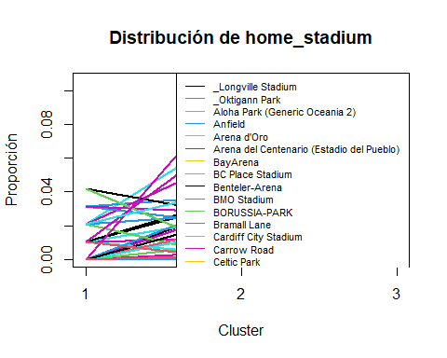
##
## ====================================
## VARIABLE: def_style
##
## Cross Table:
## c3
## var_cat 1 2 3
## Balanced 45 269 111
## Press after possession loss 26 59 27
## Pressure on heavy touch 25 68 28
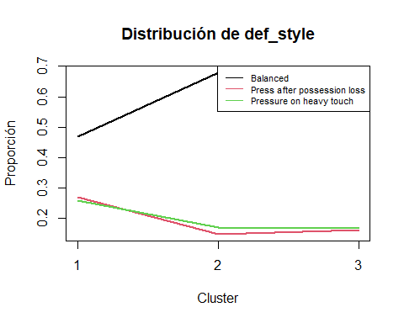
##
## ====================================
## VARIABLE: def_team_width
##
## Estadísticos por grupos:
##
## Grupo 1
## Min. 1st Qu. Median Mean 3rd Qu. Max.
## 31.0 51.0 51.0 53.5 61.0 71.0
##
## Grupo 2
## Min. 1st Qu. Median Mean 3rd Qu. Max.
## 41.00 51.00 51.00 53.05 61.00 81.00
##
## Grupo 3
## Min. 1st Qu. Median Mean 3rd Qu. Max.
## 31.00 51.00 51.00 51.84 61.00 71.00
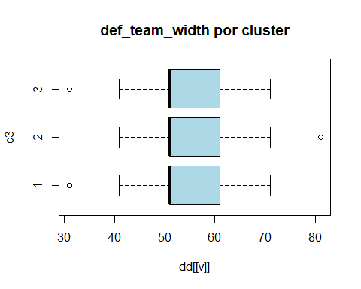
##
## ====================================
## VARIABLE: def_team_depth
##
## Estadísticos por grupos:
##
## Grupo 1
## Min. 1st Qu. Median Mean 3rd Qu. Max.
## 37 51 51 57 61 81
##
## Grupo 2
## Min. 1st Qu. Median Mean 3rd Qu. Max.
## 37.00 51.00 51.00 52.59 61.00 81.00
##
## Grupo 3
## Min. 1st Qu. Median Mean 3rd Qu. Max.
## 37.0 51.0 51.0 51.8 61.0 81.0
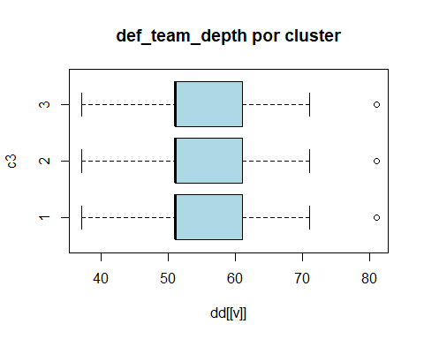
##
## ====================================
## VARIABLE: off_build_up_play
##
## Cross Table:
## c3
## var_cat 1 2 3
## Balanced 25 171 1
## Fast build up 22 3 164
## Long ball 14 105 1
## Slow build up 35 117 0
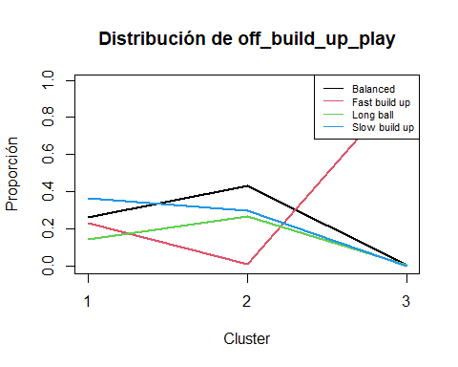
##
## ====================================
## VARIABLE: off_chance_creation
##
## Cross Table:
## c3
## var_cat 1 2 3
## Balanced 25 171 1
## Direct passing 14 105 1
## Forward runs 22 3 164
## Possession 35 117 0
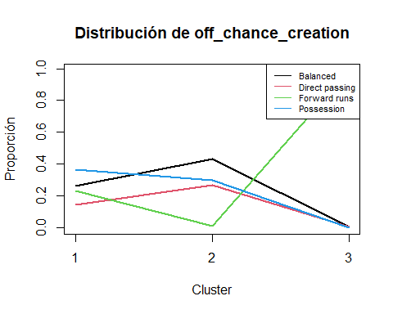
##
## ====================================
## VARIABLE: off_team_width
##
## Estadísticos por grupos:
##
## Grupo 1
## Min. 1st Qu. Median Mean 3rd Qu. Max.
## 41.00 51.00 61.00 61.83 71.00 81.00
##
## Grupo 2
## Min. 1st Qu. Median Mean 3rd Qu. Max.
## 31.00 51.00 61.00 59.48 61.00 81.00
##
## Grupo 3
## Min. 1st Qu. Median Mean 3rd Qu. Max.
## 41.00 51.00 61.00 58.83 61.00 81.00
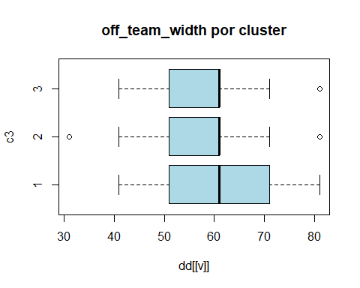
##
## ====================================
## VARIABLE: off_players_in_box
##
## Estadísticos por grupos:
##
## Grupo 1
## Min. 1st Qu. Median Mean 3rd Qu. Max.
## 3.000 4.000 4.000 4.708 6.000 8.000
##
## Grupo 2
## Min. 1st Qu. Median Mean 3rd Qu. Max.
## 3.000 3.000 4.000 4.152 5.000 8.000
##
## Grupo 3
## Min. 1st Qu. Median Mean 3rd Qu. Max.
## 3.000 3.000 4.000 4.006 4.750 8.000
